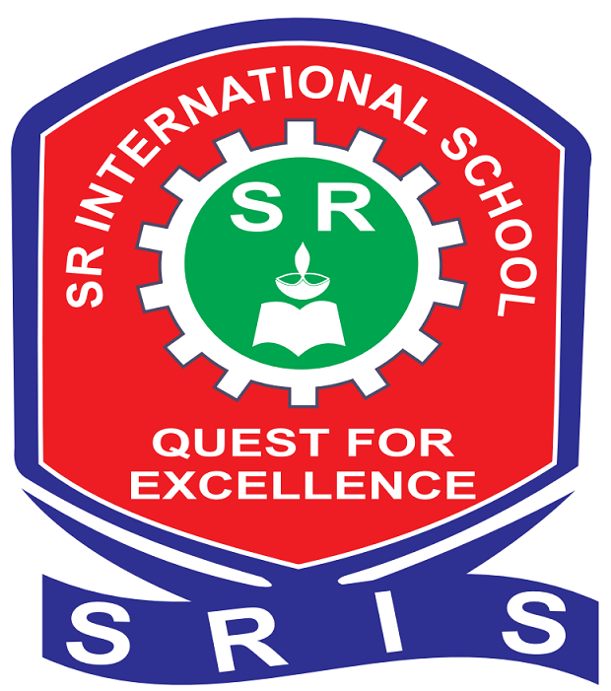 | SR | INTERNATIONAL SCHOOL  (An English Medium, Co-ed., CBSE Based School)  BAWAN ROAD, BHITHARI, HARDOI (U.P.)  Contact no. 7388077844,9305218570,9044305817

DATE: 18-09-2024

Dear parents,
It is to inform you all that the TERM- 1 EXAMINATION of all classes will start from 24-09-2024. Kindly help your child or children in preparing for these examinations.
The hard copy of scheme and syllabus has been provided to you and the soft copy has been posted on school website.

With regards
Prince ajai singh
PRINCIPAL

